**Without Forwarding:**

**index.jsp:**

<%@ page language="java" contentType="text/html; charset=ISO-8859-1"

pageEncoding="ISO-8859-1"%>

<!DOCTYPE html>

<html>

<head>

<meta charset="ISO-8859-1">

<title>Index</title>

</head>

<body>

<form action="abc.jsp">

Enter ID: <input type="text" name="id"><br>

Enter Name: <input type="text" name="name"><br>

Enter Address: <input type="text" name="address"><br>

<input type="submit" value="submit">

</form>

</body>

</html>

**abc.jsp:**

<%@ page language="java" contentType="text/html; charset=ISO-8859-1"

pageEncoding="ISO-8859-1"%>

<!DOCTYPE html>

<html>

<head>

<meta charset="ISO-8859-1">

<title>Insert title here</title>

</head>

<body>

<jsp:useBean id="u" class="student.student"></jsp:useBean>

<jsp:setProperty property="*" name="u"/>

<h2>The record is</h2>

ID:<jsp:getProperty property="id" name="u"/><br>

Name:<jsp:getProperty property="name" name="u"/><br>

Address:<jsp:getProperty property="address" name="u"/>

</body>

</html>

**student.java:**

package student;

public class student {

String id, name, address;

public String getId() {

return id;

}

public void setId(String id) {

this.id = id;

}

public String getName() {

return name;

}

public void setName(String name) {

this.name = name;

}

public String getAddress() {

return address;

}

public void setAddress(String address) {

this.address = address;

}

}

**Output:**

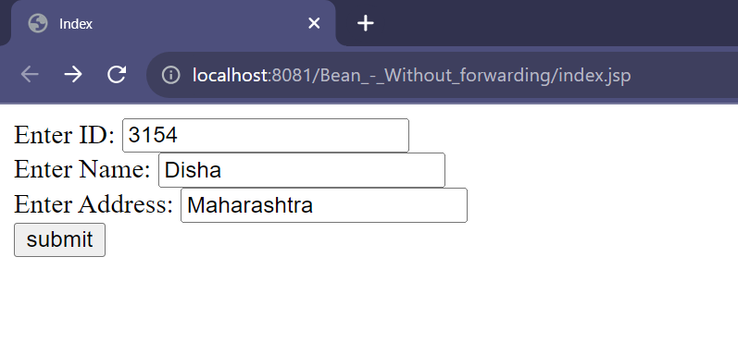

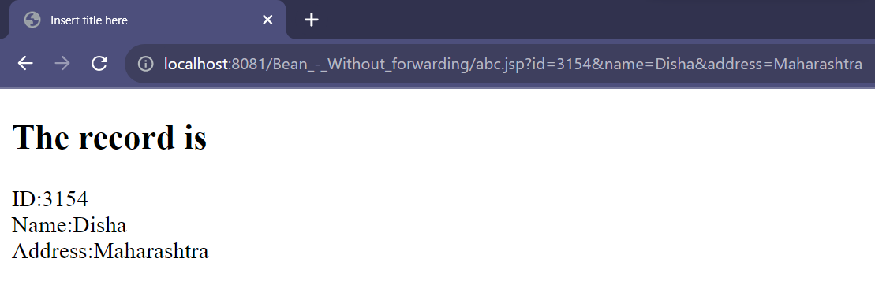

**With Forwarding:**

**index.jsp:**

<%@ page language="java" contentType="text/html; charset=ISO-8859-1"

pageEncoding="ISO-8859-1"%>

<!DOCTYPE html>

<html>

<head>

<meta charset="ISO-8859-1">

<title>Index</title>

</head>

<body>

<form action="abc.jsp">

Enter Roll no.: <input type="text" name="id"><br><br>

Enter Name: <input type="text" name="name"><br><br>

Enter Address: <input type="text" name="address"><br><br>

<input type="submit" value="Submit">

</form>

</body>

</html>

**abc.jsp:**

<%@ page language="java" contentType="text/html; charset=ISO-8859-1"

pageEncoding="ISO-8859-1"%>

<!DOCTYPE html>

<html>

<head>

<meta charset="ISO-8859-1">

<title>abc</title>

</head>

<body>

<jsp:useBean id="u" class="pack.student" scope="request"></jsp:useBean>

<jsp:setProperty property="*" name="u"/>

<jsp:forward page="print.jsp"></jsp:forward>

</body>

</html>

**print.jsp:**

<%@ page language="java" contentType="text/html; charset=ISO-8859-1"

pageEncoding="ISO-8859-1"%>

<!DOCTYPE html>

<html>

<head>

<meta charset="ISO-8859-1">

<title>print</title>

</head>

<body>

<jsp:useBean id="u" class="pack.student" scope="request"></jsp:useBean>

<jsp:setProperty property="*" name="u"/>

<h2>The record is</h2>

ID:<jsp:getProperty property="id" name="u"/><br>

Name:<jsp:getProperty property="name" name="u"/><br>

Address:<jsp:getProperty property="address" name="u"/>

</body>

</html>

**student.java:**

package pack;

public class student {

String id, name, address;

public String getId() {

return id;

}

public void setId(String id) {

this.id = id;

}

public String getName() {

return name;

}

public void setName(String name) {

this.name = name;

}

public String getAddress() {

return address;

}

public void setAddress(String address) {

this.address = address;

}

}

**Output:**

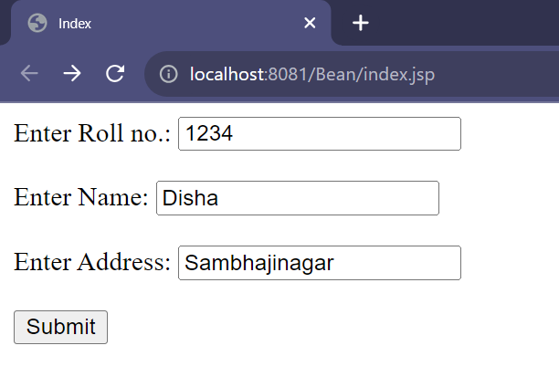

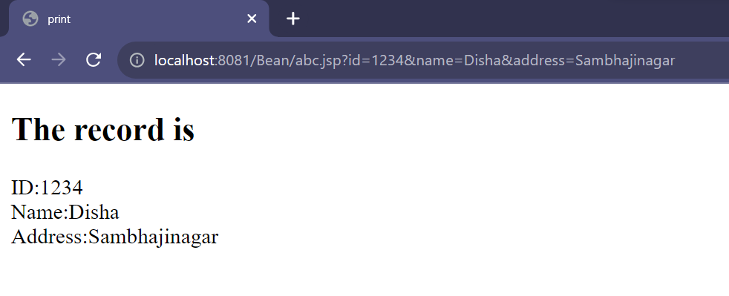

**Manual’s Example:**

**index.jsp:**

<%@ page language="java" contentType="text/html; charset=ISO-8859-1"

pageEncoding="ISO-8859-1"%>

<!DOCTYPE html>

<html>

<head>

<meta charset="ISO-8859-1">

<title>Index</title>

</head>

<body>

<form method=post action="savename.jsp">

What's your name?

<input type = text name=username size=20><br>

What's your e-mail address?

<input type = text name=email size=20><br>

What's your age?

<input type = text name=age size=4><br>

<p><input type = submit>

</form>

</body>

</html>

**savename.jsp:**

<%@ page language="java" contentType="text/html; charset=ISO-8859-1"

pageEncoding="ISO-8859-1"%>

<!DOCTYPE html>

<html>

<head>

<meta charset="ISO-8859-1">

<title>savename</title>

</head>

<body>

<jsp:useBean id="user" class="user.UserData" scope="session"/>

<jsp:setProperty name="user" property="*"/>

<a href="nextPage.jsp">Continue</a>

</body>

</html>

**nextPage.jsp:**

<%@ page language="java" contentType="text/html; charset=ISO-8859-1"

pageEncoding="ISO-8859-1"%>

<!DOCTYPE html>

<html>

<head>

<meta charset="ISO-8859-1">

<title>nextPage</title>

</head>

<body>

<jsp:useBean id="user" class="user.UserData" scope="session"/>

You entered<br>

Name: <%= user.getUsername() %><br>

Email: <%= user.getEmail() %><br>

Age: <%= user.getAge() %><br>

</body>

</html>

**UserData.java:**

package user;

public class UserData {

String username;

String email;

int age;

public void setUsername(String value) {

username = value;

}

public void setEmail(String value) {

email = value;

}

public void setAge(int value) {

age = value;

}

public String getUsername() {

return username;

}

public String getEmail() {

return email;

}

public int getAge() {

return age;

}

}

**Output:**

